Programming Questions

1a.

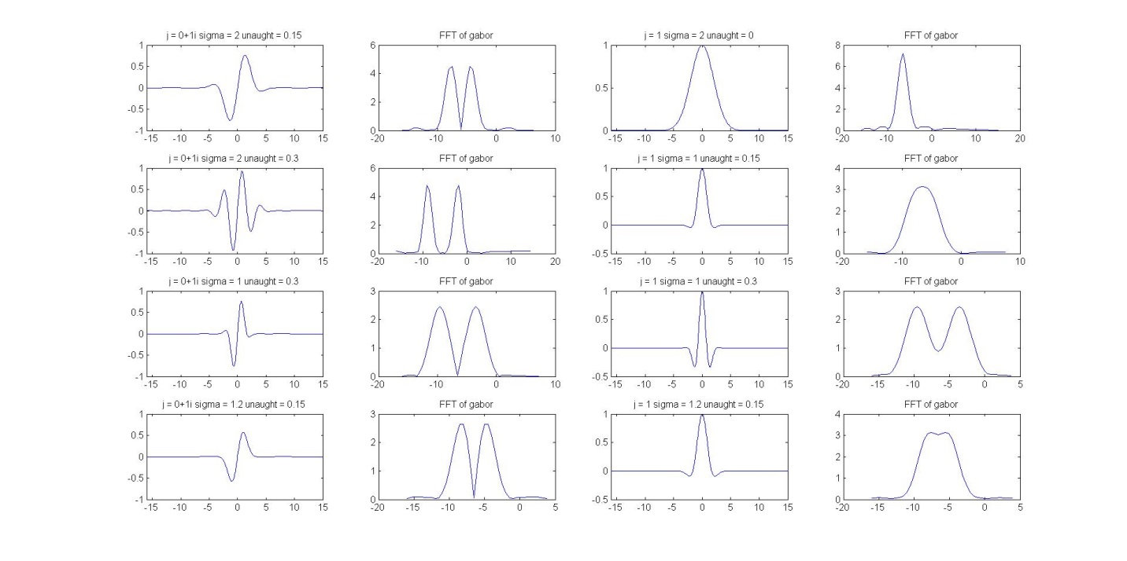

1b.

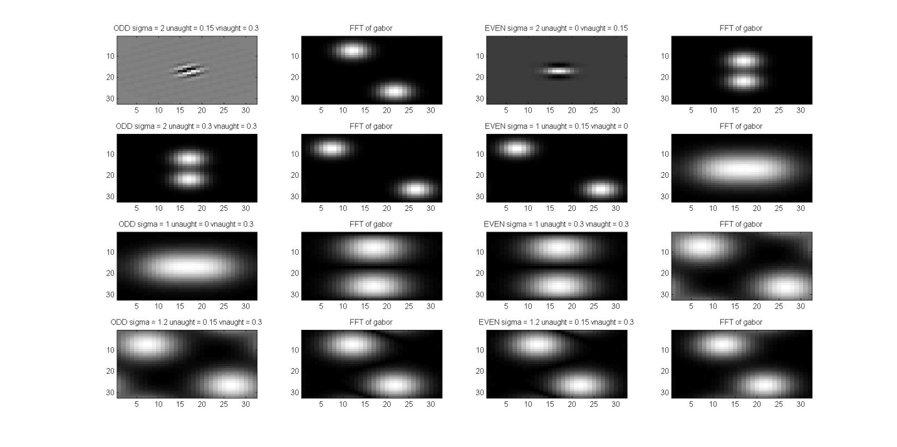

1c.

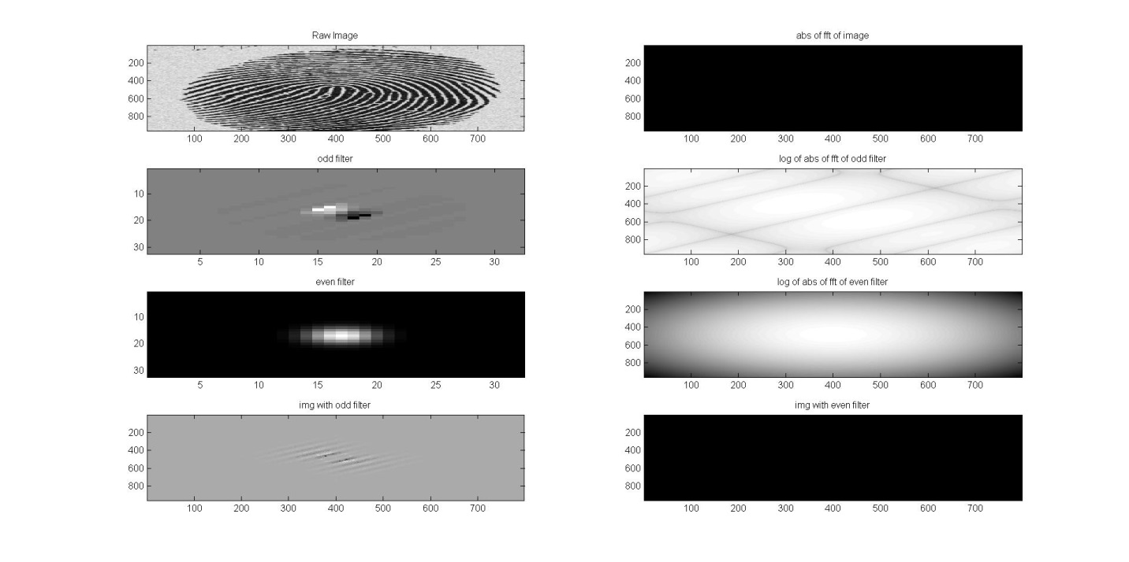

2ab.

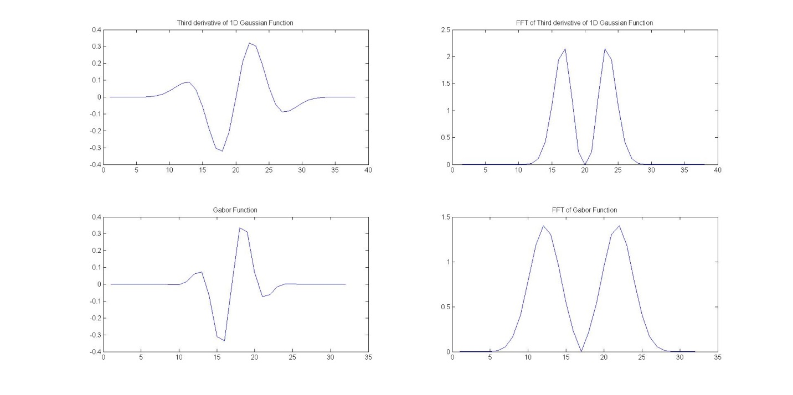

3b.

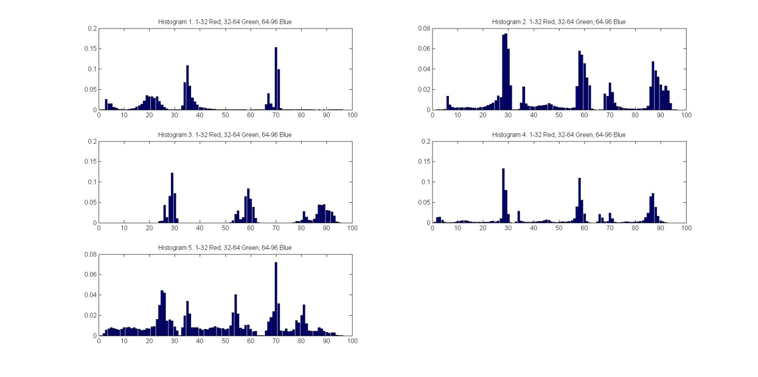

The peaks represent that there are a significant amount of pixels that fall within the range of a specific bin in a certain r, g, or b color space.

3c.

histd =

NaN 0.6873 0.9664 0.6999 0.3760

0.6873 NaN NaN 0.2275 0.4009

0.9664 NaN NaN NaN 0.5769

0.6999 0.2275 NaN NaN 0.4520

0.3760 0.4009 0.5769 0.4520 0

For entry 2,1: 0.6873, we compute the x2 distance between histogram 2 and 1. It’s somewhat high compared to the other values because they both share peaks for bins near x = 70 and 35.

For entry 3,1: 0.9664, we compute the x2 distance between histogram 3 and 1. It’s really high compared to the other values because they don’t share any peak locations.

For entry 5,1: 0.3760, we compute the x2 distance between histogram 3 and 1. It’s really low compared to the other values because they both have peaks at the same locations.

function hw4q1a

j = 1i;

sigma = 2;

unaught = 0.15;

gabor1d = @(x)(gabor1dfun(x,sigma,unaught, j));

figure;

subplot(4,4,1);

fplot(gabor1d, [-16 15]);

title(['j = ', num2str(j), ' sigma = ', num2str(sigma), ' unaught = ', num2str(unaught)]);

[x y] = fplot(gabor1d, [-16 15]);

x = x(1:8:end);

y = y(1:8:end);

ffty = (fftshift(abs(fft(y))));

subplot(4,4,2);

plot(x, ffty);

title('FFT of gabor');

j = 1;

sigma = 2;

unaught = 0.0;

gabor1d = @(x)(gabor1dfun(x,sigma,unaught, j));

subplot(4,4,3);

fplot(gabor1d, [-16 15]);

title(['j = ', num2str(j), ' sigma = ', num2str(sigma), ' unaught = ', num2str(unaught)]);

[x y] = fplot(gabor1d, [-16 15]);

x = x(1:8:end);

y = y(1:8:end);

ffty = (fftshift(abs(fft(y))));

subplot(4,4,4);

plot(x, ffty);

title('FFT of gabor');

j = 1i;

sigma = 2;

unaught = 0.3;

gabor1d = @(x)(gabor1dfun(x,sigma,unaught, j));

subplot(4,4,5);

fplot(gabor1d, [-16 15]);

title(['j = ', num2str(j), ' sigma = ', num2str(sigma), ' unaught = ', num2str(unaught)]);

[x y] = fplot(gabor1d, [-16 15]);

x = x(1:8:end);

y = y(1:8:end);

ffty = (fftshift(abs(fft(y))));

subplot(4,4,6);

plot(x, ffty);

title('FFT of gabor');

j = 1;

sigma = 1;

unaught = 0.15;

gabor1d = @(x)(gabor1dfun(x,sigma,unaught, j));

subplot(4,4,7);

fplot(gabor1d, [-16 15]);

title(['j = ', num2str(j), ' sigma = ', num2str(sigma), ' unaught = ', num2str(unaught)]);

[x y] = fplot(gabor1d, [-16 15]);

x = x(1:8:end);

y = y(1:8:end);

ffty = (fftshift(abs(fft(y))));

subplot(4,4,8);

plot(x, ffty);

title('FFT of gabor');

j = 1i;

sigma = 1;

unaught = 0.3;

gabor1d = @(x)(gabor1dfun(x,sigma,unaught, j));

subplot(4,4,9);

fplot(gabor1d, [-16 15]);

title(['j = ', num2str(j), ' sigma = ', num2str(sigma), ' unaught = ', num2str(unaught)]);

[x y] = fplot(gabor1d, [-16 15]);

x = x(1:8:end);

y = y(1:8:end);

ffty = (fftshift(abs(fft(y))));

subplot(4,4,10);

plot(x, ffty);

title('FFT of gabor');

j = 1;

sigma = 1;

unaught = 0.3;

gabor1d = @(x)(gabor1dfun(x,sigma,unaught, j));

subplot(4,4,11);

fplot(gabor1d, [-16 15]);

title(['j = ', num2str(j), ' sigma = ', num2str(sigma), ' unaught = ', num2str(unaught)]);

[x y] = fplot(gabor1d, [-16 15]);

x = x(1:8:end);

y = y(1:8:end);

ffty = (fftshift(abs(fft(y))));

subplot(4,4,12);

plot(x, ffty);

title('FFT of gabor');

j = 1i;

sigma = 1.2;

unaught = 0.15;

gabor1d = @(x)(gabor1dfun(x,sigma,unaught, j));

subplot(4,4,13);

fplot(gabor1d, [-16 15]);

title(['j = ', num2str(j), ' sigma = ', num2str(sigma), ' unaught = ', num2str(unaught)]);

[x y] = fplot(gabor1d, [-16 15]);

x = x(1:8:end);

y = y(1:8:end);

ffty = (fftshift(abs(fft(y))));

subplot(4,4,14);

plot(x, ffty);

title('FFT of gabor');

j = 1;

sigma = 1.2;

unaught = 0.15;

gabor1d = @(x)(gabor1dfun(x,sigma,unaught, j));

subplot(4,4,15);

fplot(gabor1d, [-16 15]);

title(['j = ', num2str(j), ' sigma = ', num2str(sigma), ' unaught = ', num2str(unaught)]);

[x y] = fplot(gabor1d, [-16 15]);

x = x(1:8:end);

y = y(1:8:end);

ffty = fftshift(abs(fft(y)));

subplot(4,4,16);

plot(x, ffty);

title('FFT of gabor');

end

function Y=gabor1dfun(x,sigma,unaught, j)

if(j == 1)

Y = exp(-(x^2)/(2*sigma^2)) * cos(2*pi*unaught*x);

else

Y = exp(-(x^2)/(2*sigma^2)) * sin(2*pi*unaught*x);

end

end

function hw4p1b

evenorodd = 1i;

sigma = 2;

unaught = 0.15;

vnaught = 0.3;

[x,y] = meshgrid(-16:1:15);

gab = zeros(size(x));

for i=1:size(gab,1)

for j=1:size(gab,2)

gab(i,j) = gabor2dfun(x(i,j), y(i,j), sigma, unaught, vnaught, evenorodd);

end

end

figure;

subplot(4,4,1);

imagesc(gab);

colormap('gray');

title(['ODD', ' sigma = ', num2str(sigma), ' unaught = ', num2str(unaught), ' vnaught = ', num2str(vnaught)]);

ffty = (fftshift(abs(fft2(gab))));

subplot(4,4,2);

imagesc(ffty);

colormap('gray');

title('FFT of gabor');

%%%%%%%%%%%%%%%%%%%%%%%%%%%%%%%%%%%%%%%%%%%%

evenorodd = 1;

sigma = 2;

unaught = 0.0;

vnaught = 0.15;

[x,y] = meshgrid(-16:1:15);

gab = zeros(size(x));

for i=1:size(gab,1)

for j=1:size(gab,2)

gab(i,j) = gabor2dfun(x(i,j), y(i,j), sigma, unaught, vnaught, evenorodd);

end

end

subplot(4,4,3);

imagesc(gab);

colormap('gray');

title(['EVEN', ' sigma = ', num2str(sigma), ' unaught = ', num2str(unaught), ' vnaught = ', num2str(vnaught)]);

ffty = (fftshift(abs(fft2(gab))));

subplot(4,4,4);

imagesc(ffty);

colormap('gray');

title('FFT of gabor');

%%%%%%%%%%%%%%%%%%%%%%%%%%%%%%%%%%%%%%%%%%

evenorodd = 1i;

sigma = 2;

unaught = 0.3;

vnaught = 0.3;

[x,y] = meshgrid(-16:1:15);

gab = zeros(size(x));

for i=1:size(gab,1)

for j=1:size(gab,2)

gab(i,j) = gabor2dfun(x(i,j), y(i,j), sigma, unaught, vnaught, evenorodd);

end

end

subplot(4,4,5);

imagesc(ffty);

colormap('gray');

title(['ODD', ' sigma = ', num2str(sigma), ' unaught = ', num2str(unaught), ' vnaught = ', num2str(vnaught)]);

ffty = (fftshift(abs(fft2(gab))));

subplot(4,4,6);

imagesc(ffty);

colormap('gray');

title('FFT of gabor');

%%%%%%%%%%%%%%%%%%%%%%%%%%%%%%%%%%%%%%%%%%

evenorodd = 1;

sigma = 1;

unaught = 0.15;

vnaught = 0.0;

[x,y] = meshgrid(-16:1:15);

gab = zeros(size(x));

for i=1:size(gab,1)

for j=1:size(gab,2)

gab(i,j) = gabor2dfun(x(i,j), y(i,j), sigma, unaught, vnaught, evenorodd);

end

end

subplot(4,4,7);

imagesc(ffty);

colormap('gray');

title(['EVEN', ' sigma = ', num2str(sigma), ' unaught = ', num2str(unaught), ' vnaught = ', num2str(vnaught)]);

ffty = real(fftshift(abs(fft2(gab))));

subplot(4,4,8);

imagesc(ffty);

colormap('gray');

title('FFT of gabor');

%%%%%%%%%%%%%%%%%%%%%%%%%%%%%%%%%%%%%%%%%%

evenorodd = 1i;

sigma = 1;

unaught = 0.0;

vnaught = 0.3;

[x,y] = meshgrid(-16:1:15);

gab = zeros(size(x));

for i=1:size(gab,1)

for j=1:size(gab,2)

gab(i,j) = gabor2dfun(x(i,j), y(i,j), sigma, unaught, vnaught, evenorodd);

end

end

subplot(4,4,9);

imagesc(ffty);

colormap('gray');

title(['ODD', ' sigma = ', num2str(sigma), ' unaught = ', num2str(unaught), ' vnaught = ', num2str(vnaught)]);

ffty = real(fftshift(abs(fft2(gab))));

subplot(4,4,10);

imagesc(ffty);

colormap('gray');

title('FFT of gabor');

%%%%%%%%%%%%%%%%%%%%%%%%%%%%%%%%%%%%%%%%%%

evenorodd = 1;

sigma = 1;

unaught = 0.3;

vnaught = 0.3;

[x,y] = meshgrid(-16:1:15);

gab = zeros(size(x));

for i=1:size(gab,1)

for j=1:size(gab,2)

gab(i,j) = gabor2dfun(x(i,j), y(i,j), sigma, unaught, vnaught, evenorodd);

end

end

subplot(4,4,11);

imagesc(ffty);

colormap('gray');

title(['EVEN', ' sigma = ', num2str(sigma), ' unaught = ', num2str(unaught), ' vnaught = ', num2str(vnaught)]);

ffty = (fftshift(abs(fft2(gab))));

subplot(4,4,12);

imagesc(ffty);

colormap('gray');

title('FFT of gabor');

%%%%%%%%%%%%%%%%%%%%%%%%%%%%%%%%%%%%%%%%%%

evenorodd = 1i;

sigma = 1.2;

unaught = 0.15;

vnaught = 0.3;

[x,y] = meshgrid(-16:1:15);

gab = zeros(size(x));

for i=1:size(gab,1)

for j=1:size(gab,2)

gab(i,j) = gabor2dfun(x(i,j), y(i,j), sigma, unaught, vnaught, evenorodd);

end

end

subplot(4,4,13);

imagesc(ffty);

colormap('gray');

title(['ODD', ' sigma = ', num2str(sigma), ' unaught = ', num2str(unaught), ' vnaught = ', num2str(vnaught)]);

ffty = (fftshift(abs(fft2(gab))));

subplot(4,4,14);

imagesc(ffty);

colormap('gray');

title('FFT of gabor');

%%%%%%%%%%%%%%%%%%%%%%%%%%%%%%%%%%%%%%%%%%

evenorodd = 1;

sigma = 1.2;

unaught = 0.15;

vnaught = 0.3;

[x,y] = meshgrid(-16:1:15);

gab = zeros(size(x));

for i=1:size(gab,1)

for j=1:size(gab,2)

gab(i,j) = gabor2dfun(x(i,j), y(i,j), sigma, unaught, vnaught, evenorodd);

end

end

subplot(4,4,15);

imagesc(ffty);

colormap('gray');

title(['EVEN', ' sigma = ', num2str(sigma), ' unaught = ', num2str(unaught), ' vnaught = ', num2str(vnaught)]);

ffty = (fftshift(abs(fft2(gab))));

subplot(4,4,16);

imagesc(ffty);

colormap('gray');

title('FFT of gabor');

end

function Y=gabor2dfun(x, y ,sigma,unaught, vnaught, j)

if(j == 1)

Y = exp(-(sqrt(((x^2) + (y^2))^2))/(2*sigma^2)) * cos(2*pi*(unaught*x + vnaught*y));

else

Y = exp(-(sqrt(((x^2) + (y^2))^2))/(2*sigma^2)) * sin(2*pi*(unaught*x + vnaught*y));

end

end

function hw4p2a

sigma = 3;

cfd = [1 0 -1];

dgauss = zeros(1,32);

for x=-16:1:15

dgauss(x+17) = exp(-(x^2)/(2*sigma^2));

end

res = conv2(cfd, dgauss);

res = conv2(cfd, res);

res = conv2(cfd, res);

figure;

subplot(2,2,1);

plot(res);

title('Third derivative of 1D Gaussian Function');

subplot(2,2,2);

plot(abs(fftshift(fft2(res))));

title('FFT of Third derivative of 1D Gaussian Function');

dgab = zeros(1,32);

sigma = 2.5;

unaught = .15;

for x=-16:1:15

dgab(x+17) = exp(-(x^2)/(2*sigma^2)) * sin(2*pi*unaught*x) * .45;

end

subplot(2,2,3);

plot(dgab);

title('Gabor Function');

subplot(2,2,4);

plot(abs(fftshift(fft2(dgab))));

title('FFT of Gabor Function');

end

function res = getHist(imgname)

%get rect from image

img = imread(imgname);

imshow(img);

rect = getrect;

xmin = floor(rect(1));

width = floor(rect(3));

ymin = floor(rect(2));

height = floor(rect(4));

%compute histogram

[rcount, rhist] = imhist(img(ymin:ymin+height,xmin:xmin+width,1), 32);

[gcount, ghist] = imhist(img(ymin:ymin+height,xmin:xmin+width,2), 32);

[bcount, bhist] = imhist(img(ymin:ymin+height,xmin:xmin+width,3), 32);

hist = [rcount; gcount; bcount];

totsum = 0;

for i=1:size(hist,1)

for j=1:size(hist,2)

totsum = totsum + hist(i,j);

end

end

hist = hist ./ totsum;

res = hist;

end

function res = histdist(hist1, hist2)

csum = 0;

for k=1:size(hist1,1)

temp = (hist1(k,1) - hist2(k,1))^2;

temp = temp / (hist1(k,1) + hist2(k,1));

csum = csum + temp;

end

res = csum/2;

end

function hw4p3b

hist1 = getHist('Fig0630(01)(strawberries_fullcolor).tif');

hist2 = getHist('Fig0630(01)(strawberries_fullcolor).tif');

hist3 = getHist('Fig0630(01)(strawberries_fullcolor).tif');

hist4 = getHist('Fig0630(01)(strawberries_fullcolor).tif');

hist5 = getHist('Fig0630(01)(strawberries_fullcolor).tif');

subplot(3,2,1);

bar(hist1);

title('Histogram 1. 1-32 Red, 32-64 Green, 64-96 Blue');

subplot(3,2,2);

bar(hist2);

title('Histogram 2. 1-32 Red, 32-64 Green, 64-96 Blue');

subplot(3,2,3);

bar(hist3);

title('Histogram 3. 1-32 Red, 32-64 Green, 64-96 Blue');

subplot(3,2,4);

bar(hist4);

title('Histogram 4. 1-32 Red, 32-64 Green, 64-96 Blue');

subplot(3,2,5);

bar(hist5);

title('Histogram 5. 1-32 Red, 32-64 Green, 64-96 Blue');

hists = [hist1 hist2 hist3 hist4 hist5];

histd = zeros(5,5);

for i=1:size(histd,1)

for j=1:size(histd,2)

histd(i,j) = histdist(hists(:,i),hists(:,j));

end

end

histd

end